**CURRICULAM VITATE**

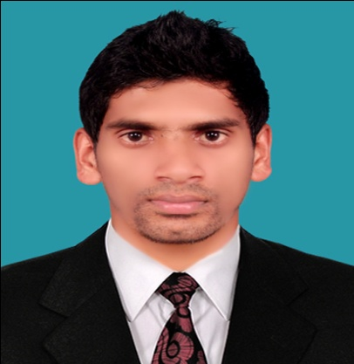**Vitae**

V.Nishanthan

Small Drayton,

Kotagala.

T.P:- 0712991266

Email: - vnishanthan90@yahoo.com

**Career Objectives**

**CAREER OBJECTIVE**

With an excellent professional in Auditing / Financial Accounting / Financial Management, where I can practice my knowledge, skills & expertise while gaining a better practical exposure in related fields and looking forward for a challenging career, where there is scope for demonstration, always on a look out for a positive & bigger outlook. Also thrive on Imagination & Passion, Rigorous thinking and boundless curiosity.

**EEDUCATIONAL QUALIFICATION Qualifications**

* **Degree** in **Bachelor of Commerce (Accountancy & Finance), Eastern University Sri Lanka.**
* **G.C.E.(A/L) Examination in Commerce stream in 2008 ( Kotagala Tamil Maha Vidyalayam )**
* Economics - A
* Accountancy - B
* Business Studies - B
* **Passed G.C.E. (O/L) Examination in 2005 ( Kotagala Tamil Maha Vidyalayam )**
* Physical Studies - A
* Hinduism - A
* Tamil & Litt - A
* Mathematics - B
* Geography - B
* Social Studies - C
* Science - C
* Commerce - C
* Tamil - C
* English - S

**EWORKING EXPERIENCES**

**05/01/2014 to 06/01/2015 at - Training S.Saverimuttu & CO Chartered Accountants and Now As a Accounts & Admin Officer at Berendina Development Service (Get) Ltd.**

* Prepared summarized Profit & Loss Account, Balance Sheet and Cash flow Statement.
* Test checked posting to General Ledger Control Account and Profit & Loss Account via vouchers.
* Express an opinion on the bank’s financial statements, which are prepared in accordance with an identified financial reporting framework.
* Checked reconciliation statement.
* Checked the balance outstanding in the subsidiary ledger cards with the general Ledger.
* I have been done World Bank project accounting.
* I have Experience in SAP

**P EPROFOSSIONAL QUALIFICATION**

* Successfully completed in CA - The Institute of Chartered Accountants of Sri

Lanka.

* Foundation level
* Intermediate level ( CAB-2)
* Completed Diploma in Computerized Accounting (**Quick Book**, SPSS & **MS-Office**).

**Research & Public**

**ERESEARCH & PUBLICATION**

* “ The Appraisal of Cost Accounting Practices in Plantation Companies “
* Computerized Accounting Projects

**SINTERESTED WORKING FIELDS**

* Auditing
* Financial Accounting
* Financial Management
* Inventory Management

**S****EXTRA-CURRICULAR ACTIVITY**

* Head prefect in School.
* Member of Small Drayton Sports Club
* Member of English Literary Association in School.
* I have participated in 10th “Sri Lanka University Games 2010.
* I have participated in the “Sri Lanka Inter university Football match” on 2009, 2010, 2011 and 2012.

**S****PERSONAL PROFILE**

* Full Name :- Velayudam Nishanthan
* Date of Birth :- 1990.01.14
* NIC No :- 900140282V
* Sex :- Male
* Marital Status :- Single
* School Attended: - Kotagala Tamil Maha vidyalyam.

**Ra-C**

**S****NON RELATED REFEERES**

* Mr. T. Perinbaraaj

Chartered Accountants,

Thangavelu & co,

P.O.Box: 936, 3rd Floor,

Y.M.B.A. Building, Colombo-01.

T.P:- +94 11 5742104

Email: - raj1114tax@yahoo.com

* Mr. T. Paranthaman

Senior Lecturer,

Department of Commerce.

Eastern University, Sri Lanka.

T.P:-077-1128250

Email: - [paramcommerce@yahoo.com](mailto:paramcommerce@yahoo.com)

I hereby certify that the above information is true and correct according to the best of my

Knowledge.

**Related**

V.Nishanthan…… (2015.11.27)……………………..

**Sinn Ssjjsj201**